16.74: a) (See also Example 16.19 and Problem 16.66.) The wall will receive and reflect pulses at a frequency 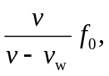 and the woman will hear this reflected wave at a frequency

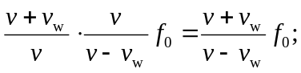

The beat frequency is

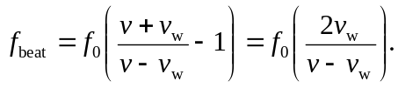

b) In this case, the sound reflected from the wall will have a lower frequency, and using 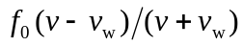 as the detected frequency (see Example 21-12; 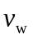 is replaced by 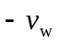 in the calculation of part (a)),

